Phishing Website/URL  
Detection

***: Wireframe Documentation :***



CREATED BY

1. **Priya Karvande**
2. **Jayesh Patil**
3. **Nikhil Dahitule**

HOME PAGE

1. When User enters the URL( <https://creditcarddefault5699.herokuapp.com/>

) it will redirect to HOME Page which looks like below..

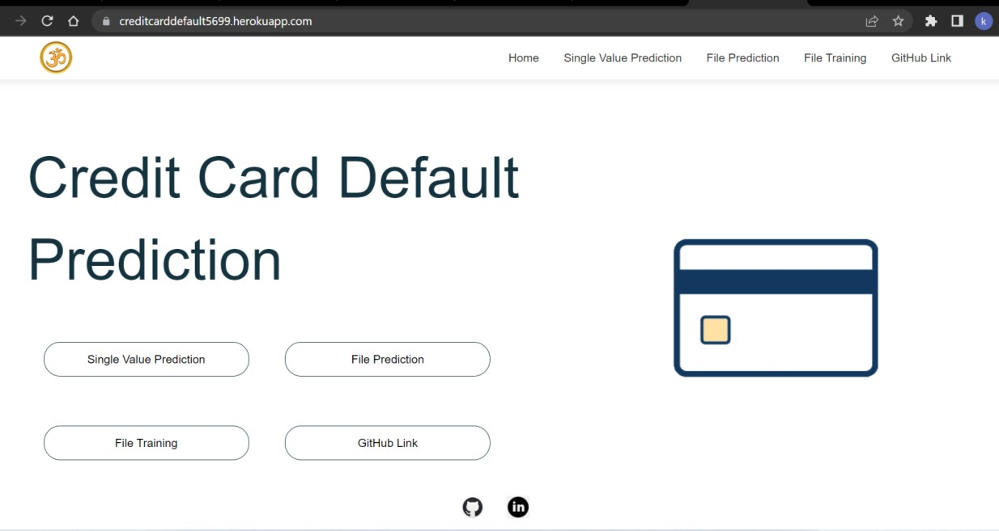

1. After that user can see options like **SingleValuePrediction**, **File Prediction**, **File Training** and **GitHub link.**
   * **SingleValuePrediction** : User need to enter all required values then he/she will get prediction.
   * **File Training** : User need to give a path to train the model.
   * **File Prediction** : After training we can get Predictions by this option.
   * **GitHub link** : Github link for this project.
2. **Single Value Prediction** : If user clicks on Single value prediction in home page then it will redirect to below page.

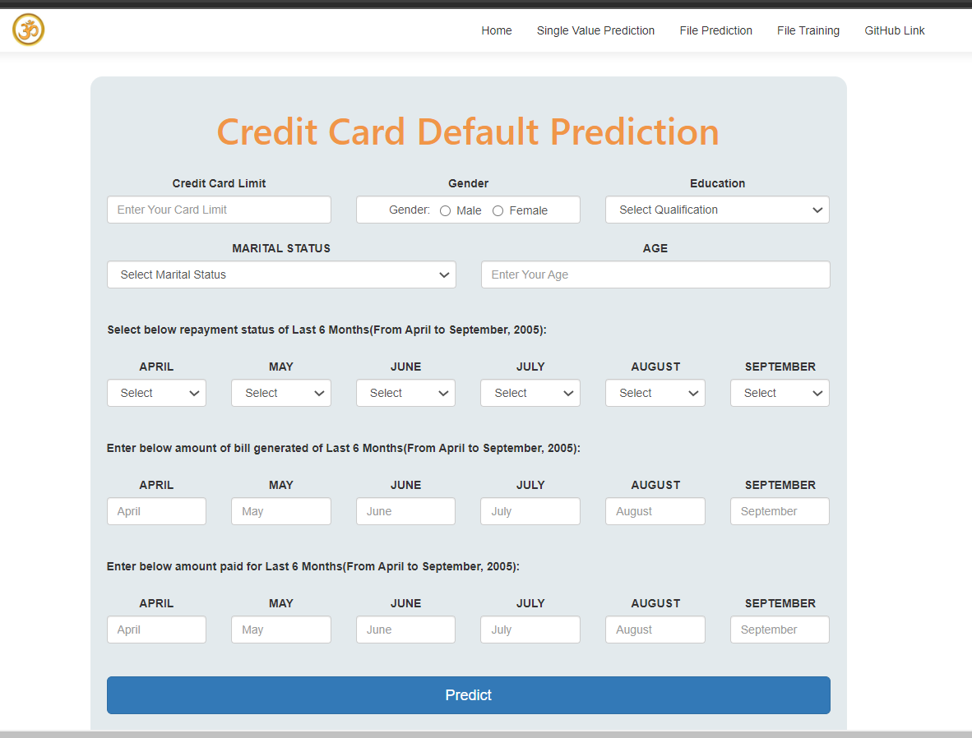

1. After user enters details like below, he/she need to click predict button to get Prediction.

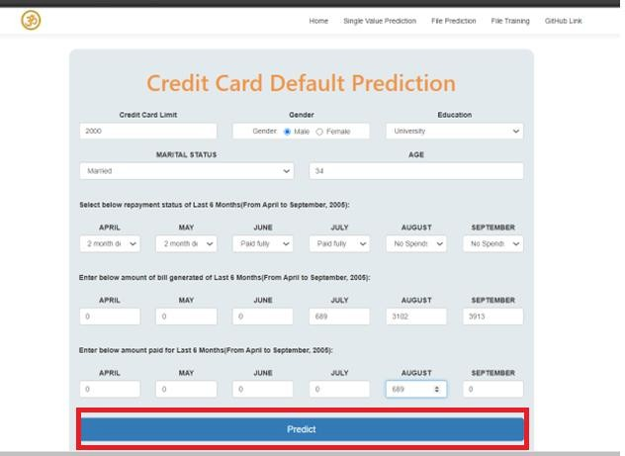

1. Prediction will show at the bottom of same page like below:

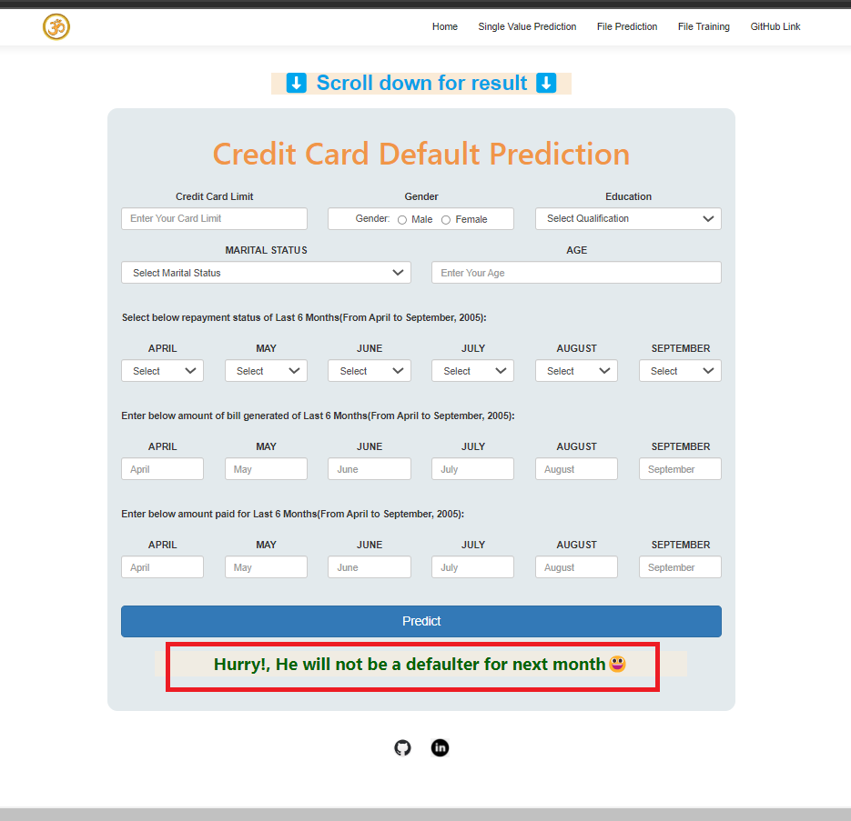

1. **File Training** : If user clicks File Training, then It will redirect to below page:

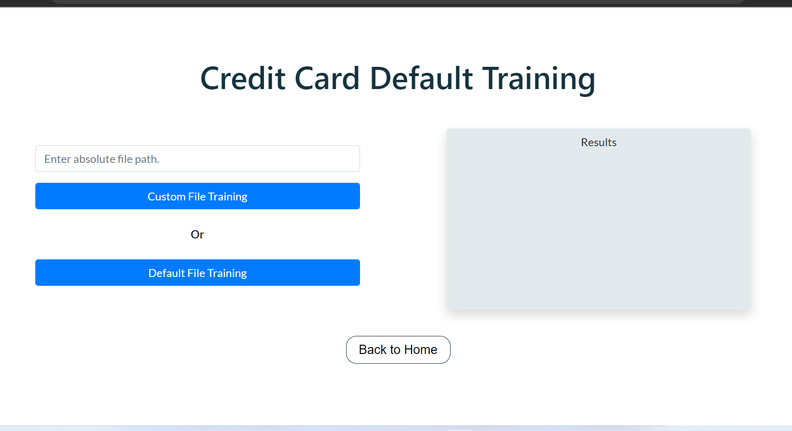

**Custom file training** : User can enter a path where trainings files are there. By using that files model will trained.

**Default file training** : Or else user can test our website by using default file training option, Which will train the model by using default training files.

1. **File Prediction** : After training completed, user can get predictions file by redirecting to this below page :

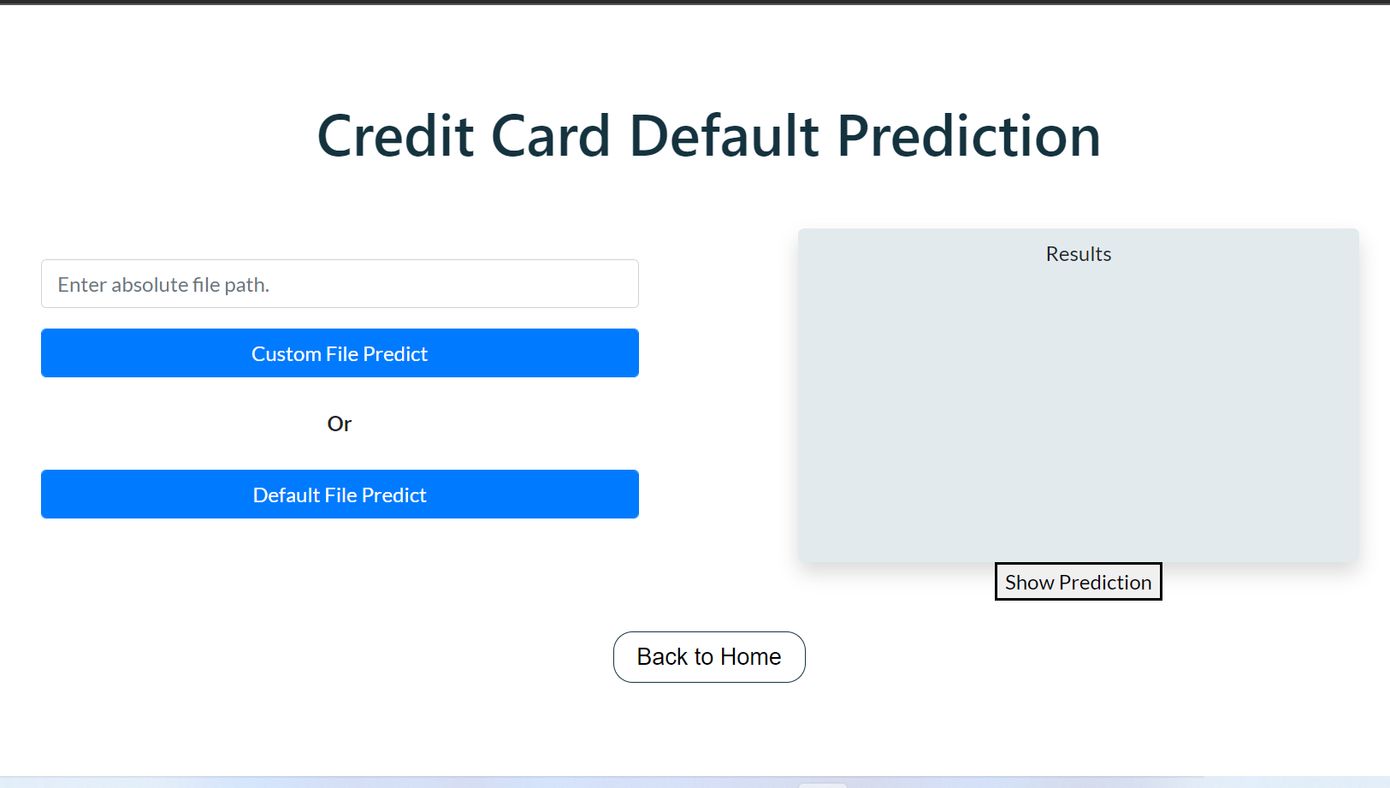

**Custom file prediction** : User can enter a path where prediction files are there. By using that files he/she will get predictions.

**Default file prediction** : Or else user can test our website by using default file prediction option. Which will give default predictions.

1. **Show Predictions** : After successful prediction. User can see predictions by clicking show predictions at below page:

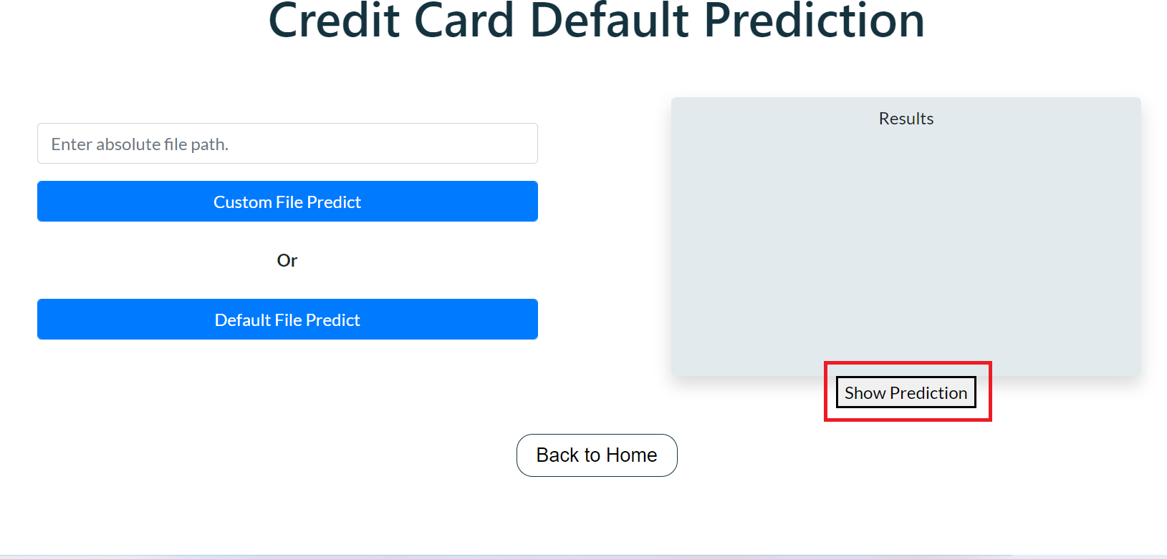

1. **Result page** : Here user can see predictions.

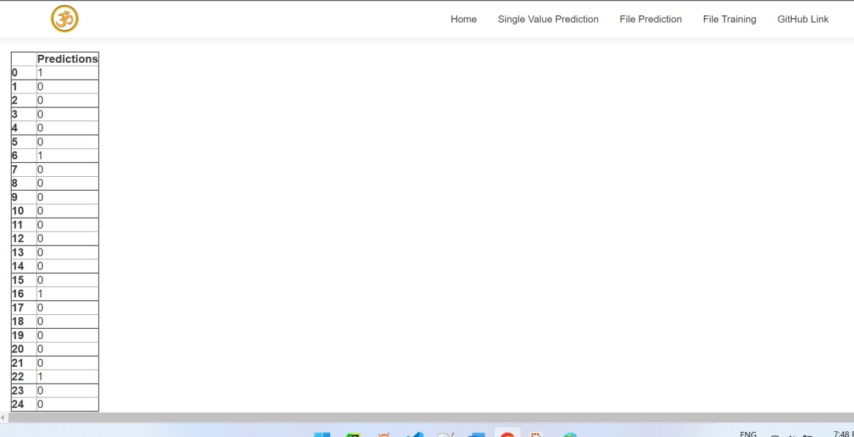

THE END